*Title Page for Digital Submission*

|  |  |  |  |  |  |  |  |  |  |  |  |  |  |
| --- | --- | --- | --- | --- | --- | --- | --- | --- | --- | --- | --- | --- | --- |
|  |  | | | | | | | | | | | |  |
|  | | | | **Macromedia University of Applied Sciences** | | | | | | | |
|  | | | | | | | | | | | |
|  | | | | **Course Title:** Advanced coding  **Name of Examiner:** Ahmet Yildiz, William Baker Morrison | | | | | | | |
|  |  | | | | | | | | | | | |
|  | **To be completed by students:** | | | | | | | | | | | |  |
| B-306269 | | | | | | |  | | B-UBr DT SWE 6e 24W | | |  |
| Student ID number | | | | | | |  | | Matriculation | | |  |
| Kandirmaz | | | | | | |  | | Sueda Gul | | |  |
| Last name | | | | | | |  | | First name | | |  |
| The student work will be submitted as:  (Please fill in the letter X in the appropriate box) | | | | | | | | | | | |  |
|  | | | | | | | | | | | |  |
|  | x | | Individual work | | | | | | | | |  |
|  | | | | | | | | | | | |  |
|  |  | | Group work | | | | | | | | |  |
|  | | | | | | | | | | | |  |
|  |  | | | | | | | | | | | |  |
|  | **Does only apply to group work:** (Complete only if it is a group work)  **If you are submitting a group work, please list the first and last names of all group members. The names must be entered electronically by the respective group members themselves. By entering the name, it is confirmed that the student agrees to submit the paper in the present form.** | | | | | | | | | | | |  |
| If you submit a group assignment, please list the first and last names of all group members. By entering their names, the students confirm that they agree to the assignment being submitted in its current form. The contribution of each group member must be indicated in the assignment (e.g. in the outline or chapter headings). Furthermore, by entering their name, the student declares that the entire project work, and in particular the part created by each group member, has been produced independently and without outside help. No aids other than those listed in the attached list of sources and AI tools have been used. All passages taken verbatim or paraphrased from publications are identified as such. Content generated using AI has been marked at the relevant point. Furthermore, it is confirmed that the use of AI tools and AI-supported aids is listed in full in the attached AI directory. It is also assured that all AI-generated content has been checked to the best of our knowledge and belief and in accordance with the general principles of good scientific practice. The work has not yet been submitted to any examination authority in the same or a similar form. By submitting the work, the group members agree that all assessments and comments made by the examiners will be stored in the uploaded work. The group member who uploaded the work must make the correction notes available to the other group members. | | | | | | | | | | | |  |
|  | | | | | | | | | | | |
| 1) | |  | | | |  | | 5) | | |  |
| 2) | |  | | | |  | | 6) | | |  |
| 3) | |  | | | |  | | 7) | | |  |
| 4) | |  | | | |  | | 8) | | |  |
|  | | | | | | | | | | | |
| Assessment of group work:  (Please fill in the letter X in the appropriate box) | | | | | | | | | | | |
|  | | | | | | | | | | | |
|  |  | | I apply for an individual evaluation (i.e. each member of the group will receive an individual mark) | | | | | | | | |
|  | | | | | | | | | | | |
|  |  | | I apply for a group evaluation (i.e. each member of the group receives an identical grade) | | | | | | | | |
|  | | | | | | | | | | | |
|  | Berlin/ 26.06.2025 | | | | |  | | | | | Sueda Gul Kandirmaz | |  |
|  | Place/Date | | | | |  | | | | | Complete First Name and Last Name | |  |
|  | **Evaluation (according to grading scale), result of initial inspection: total points: _______**  **Date: Name, first name First Examiner (to be filled in digitally)** | | | | | | | | | | | |  |
|  | **To be completed by the examiner:** (Text area for the second examiner) | | | | | | | | | | | |  |
|  |  | | | | | | | | | | | |  |
|  | *Title Page for Digital Submission, Macromedia version 05/2025* | | | | | | | | | | | |  |

**ADVANCED CODING PROJECT**

*By SUEDA GUL KANDIRMAZ*

WHY THIS PROJECT ?

Most applications to reshape society offer the latest ways to benefit people. In my project, I focused on it especially for agricultural workers and people who love growing plants to understand how plants can easily find the disease. My application helps people to some extent with some problems they encounter when growing a plant. It can also help people who need fast and reliable solutions and those who have little time. This useful approach in the application makes it easier for individuals to grow plants. Therefore, sometimes people want to grow plants but are afraid and do not do it, this situation leads people to this situation and they can easily cope. When I consider this application and its features, this project is fun for beginners, although it is complicated to do, it is entertaining, informative and educational. The main reason I chose this project is because my father grows plants in a greenhouse and I can help him.

WHAT IS THE APP?

This project can be called “Plant Disease Detection”. It is an application that can understand plant diseases of users. This application is a Python-based system that allows users to upload a plant leaf photo and receive AI-powered disease detection. Backend API was created with Flask, image classification was done with PyTorch, SQLite database was used and image processing was done with Pillow. And I also used the dataset I got from Kaggle. The dataset name is PlantVillage. This dataset was divided into curved models.

Technologies Used

Python: Used as the main programming language of the application.

Flask: Used to establish the REST API structure.

SQLite: Used for data persistence of training and prediction records.

PyTorch: Created and trained a deep learning model for visual classification.

Pillow: Used for processing images.

HTML: Used for basic user interface design.

Properties

The user uploads a plant leaf image via HTML form.

The uploaded image is analyzed by a deep learning model trained using PyTorch.

The disease class to which the image belongs is detected and presented to the user.

Training and prediction processes are recorded in the SQLite database.

The code structure was developed according to the principles of object-oriented programming.

Inheritance and modular structure (packages and modules) were used effectively.

HOW DOES APP WORK?

Figure

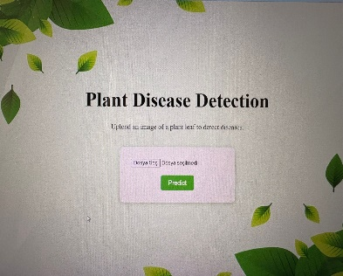 After you run the app_flask.py file, you go to the URL and a page appears as seen in this image. You add the diseased plant leaf there and when you say predict, the name of the disease in the figure 2 appears.

Figure 2

The plant disease in figure 3 is tomato bacterial spot.

**Figure 3**

Figure

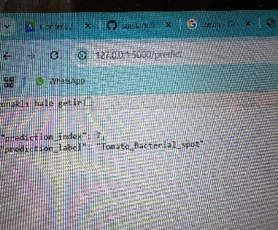

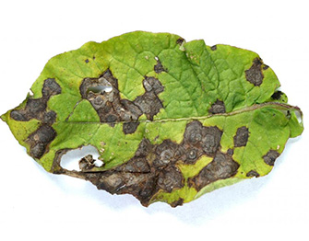

OBJECT-ORIENTED PROGRAMMING(OOP):

In this project, it provides a modular and readable structure by collecting data and functions in classes. This makes code maintenance easier and speeds up testing and development processes.

DESCRIPTION OF PROJECT FILES:

dataset_loader.py file is to load a dataset into the program properly and in a developed way.

predictor.py file is used to validate with pytorch and save the best model.

cnn_mode.py learning the deteriorations from the plant's visual, it:

* Is it sick or healthy?
* Which disease?

db_handler.py file connecting to a database, that is, connecting to another database with SQLite.

image_utils.py file makes the operations performed to prepare images for training or prediction organized, reusable and simple in a central file.

index.html file is the main home page of the web application.

model_trainer.py file allows the model to learn on data and saves the best performing model at the end.

main.py file is the main control center. It runs the application by calling functions defined in other files.

app_flask.py file is to start the Flask web server and allow users to interact with the model via the REST API over the web. Also, when I run this in my project, my project works and you can upload images.

split_dataset.py file means dividing the dataset into different parts: training, validation and testing.

GITHUB LINK: <https://github.com/suedagulkandirmaz/advanced-coding-project>